NJ Business Action Center
Placemaking Guidelines
Purpose
The following brief guidelines may be used and adapted to promote quality and appropriate design characteristics in a mixed-use district for placemaking projects in the public realm. These guidelines reflect best practices in present-day placemaking concepts and would help public and private entities make effective investments as they seek to improve their properties’ and district’s appearance. Structured as guidelines, they are not regulatory in nature, unless a municipality or district management entity chooses to adopt them.

NJ Business Action Center

Placemaking Guidelines

2024

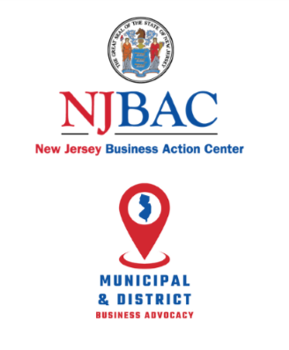

NJ Business Action Center Placemaking Guidelines
The guidelines in this template are recommended for all other placemaking projects in a mixed-use district. They are designed for the creation of new places and enhancement of existing places. The template may be adapted to local circumstances and may be adopted as part of a zoning overlay, Master Plan, ordinance, or Redevelopment Plan by a municipality. Alternatively, the guidelines could be adopted by a District Management Entity for the particular district(s) where it works to support business success and revitalization.
Placemaking Background
Placemaking is a way to make a mixed-used (or any) district within your community a better place to live and work by transforming publicly accessible spaces into vibrant places. As a place becomes more desirable and welcoming, businesses' success, property value, and civic pride around that place increase. Placemaking involves using stakeholder engagement to identify spaces that need improvement, assessing their current condition, visioning the future condition, and developing action plans to transform public spaces into great places.
As a process, placemaking is a multi-faceted and participatory approach to the planning, design and management of publicly accessible spaces. Ideally, placemaking capitalizes on authentic local assets, inspiration, and potential, with the intention of creating places that promote people's health, happiness, and well-being while at the same time supporting the economic sustainability and growth of the community. Placemaking always results in creating or enhancing visible and tangible change, and if often done tactically at a low cost over a short-term period (e.g. a pilot) prior to more significant resource investment that makes changes larger and/or permanent.

Project for Public Spaces offers a helpful paradigm to consider when engaging in placemaking, i.e., planning and creating great places. Note that the experience of place has three core levels:
- Key Attributes,
- Intangibles (Qualities), and
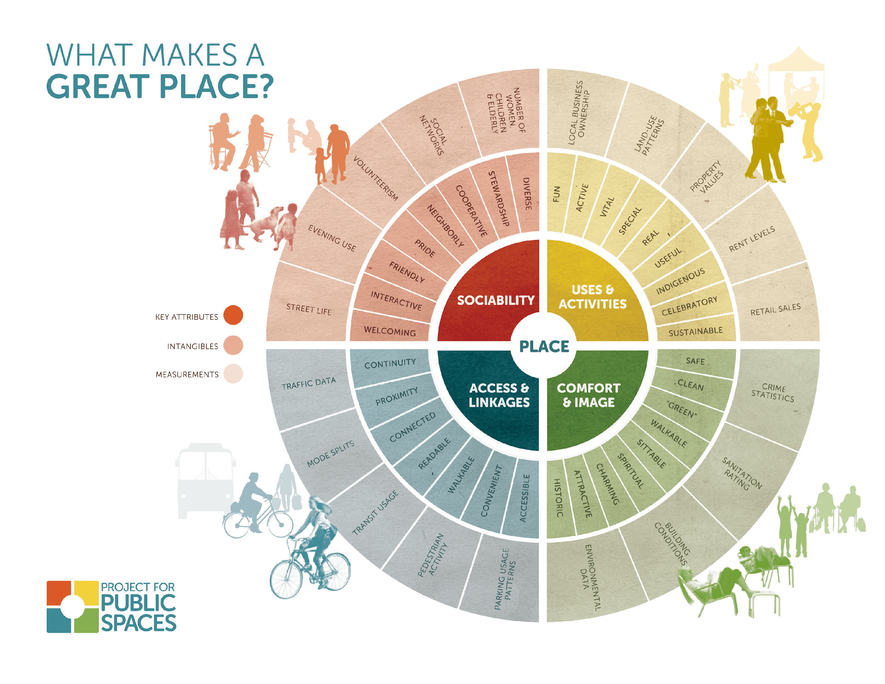
- Measurements (Data)
Place-based revitalization is best when driven by the community - The PEOPLE who live, learn, work, play, invest, and visit there.

Community-Driven visible and tangible change tends to result in enhanced community value which sustains and increases four Prosperity Values.

In terms of placemaking, these Prosperity Values can be measured in the following ways:

- Place Value - the physical/public realm - the parks, plazas, streets, and stoops - and that connective tissue between public and private space – both horizontal and vertical
  - MEASURE: do PEOPLE feel like they belong there?
- Economic Value - from anchor institutions, to mom & pops, to food cart entrepreneurs - the more cross-scale synergy, the stronger the economic value
  - MEASURE: do PEOPLE want to spend their money there?
- Social Value - We are social beings - and our districts are environments where people feel welcome, will linger, and want to visit again and again.
  - MEASURE: do PEOPLE connect with one another here, formally or organically?
- Civic Value - There is no “They” – nor is there a “Revitalization Fairy” to get this done. “They” are the engaged community - the stakeholders, the champions, and the stewards.
  - MEASURE: are PEOPLE engaged there?

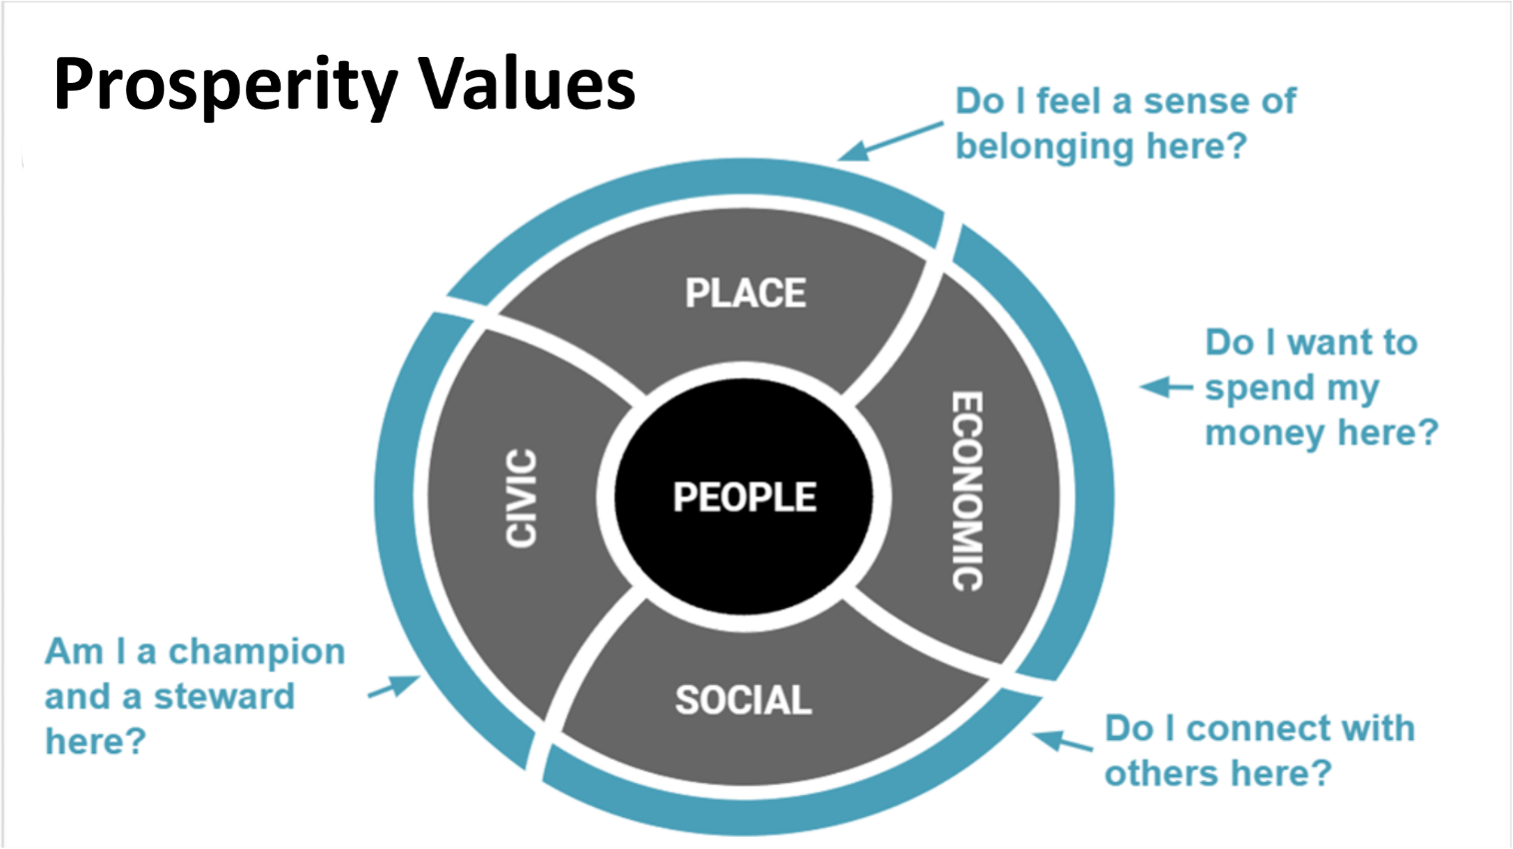
Project Accessibility Core Criteria:
- The placemaking project may be implemented on public or private property, or a combination of both.
- The project should be accessible to the public through at least one of the following ways: visible, touchable, and hearable.
- Public accessibility to the placemaking project should be maintained at least six days a week and for at least 8 hours a day.
- The project should be safely accessible for pedestrians of all ages and abilities and those using non-motorized transportation.
Project Engagement Core Criteria:
- The placemaking project should foster and/or enhance the opportunity for social and/or commercial interaction of residents, visitors, and the district workers.
- The project should be designed on a human scale.
- The project should encourage either passive or active interaction.
- The project can be purely aesthetic in nature.
- The project can be primarily functional in nature but must have an aesthetic component.
- If the project is designed with a short-term use (< 2 years) in its original location (to set the stage for future development, for example) the component parts of the project should be substantially transferrable to another site in the district for reuse and redeployment.
Project Management and Maintenance Core Criteria:
- The project should have a commitment from a District Management Organization and/or the local government for place management and maintenance to ensure long-term viability and purpose and/or
- The project should have a commitment from other organizations, service clubs, or institutions who are to be in charge of its ongoing care and programming.
- All mural projects over 1,000 square feet once completed should include a final anti-graffiti/UV-resistant/weather-protectant coating – or a repair and maintenance agreement – as part of their budget. Please let us know if you would like examples of this.
Examples of Placemaking Projects in Mixed-Use Districts:
- Alley Enhancements and Activations – Including Lighting, Seating, Art, Performance Space, Recreational Features
- District Gateways – Branded Structures Across Streets or Alleys
- Information Kiosks - On Sidewalks, in Plazas, District Parks, or Alleys; Static or Digital
- Enhanced Pedestrian Intersection or Street Crossings – Painted, Thermoplastic, or Hardscape Crosswalks; Full- or Partial-Intersection Treatments that May Include Lighting
- Pocket Parks – Natural Landscape, Public Activity Parks, Performance Parks; Hardscaping, Landscaping, Art, Lighting, Performance Space, Recreational Features
- Parklets – Including Vertical and Horizontal Structures, Plantings, Art, Seating, Lighting, Recreational Features
- Pedestrian Realm Lighting – Across or In Alleys/Plazas, Across Streets, Across or Along Sidewalks
- Pedestrian Scale Wayfinding – On Sidewalks, in Plazas or Alleys; for Businesses and Public Assets
- Plaza Creation or Enhancement – Paint, Hardscaping, Lighting, Outdoor Seating, Art, Performance Space, Recreational Features
- Public Art – Sculptures, Murals, Artistic Features, Stage Areas for Public Performances
- Public Gardens – Urban Food Gardens, Rain Gardens, Bioswales
- Public Recreational Features – Splash Pads, Musical Installations, Outdoor Games and Equipment
- Public Outdoor Seating and Dining Areas – Moveable Seating and Tables for Public Use on Sidewalks and/or in Alleys and Plazas
- Shade Features – Mature Trees, Outdoor Umbrellas, Shade Sails, Pergolas (Living or Structural)
- Transit and Non-Motorized Vehicle Shelters – Enhanced Bus/Rail Shelters, Bicycle Lockers/Storage/Stands

Note: This list serves as a framework of placemaking project examples and therefore is not limited to the items shown and described.
1. Alley and Underpass Enhancements and Activations – Including Lighting, Seating, Art, Performance Space, Recreational Features
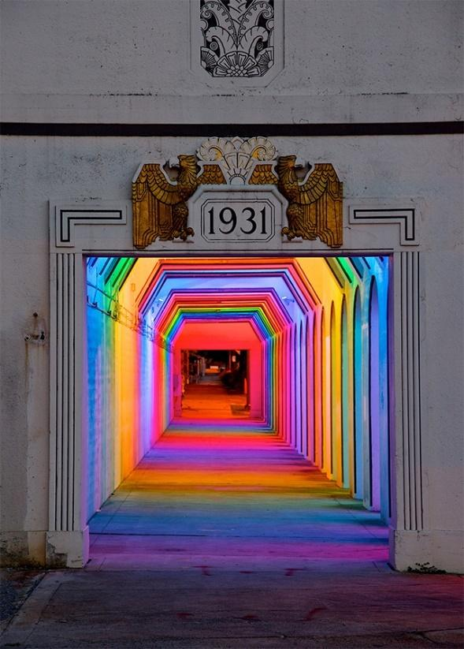
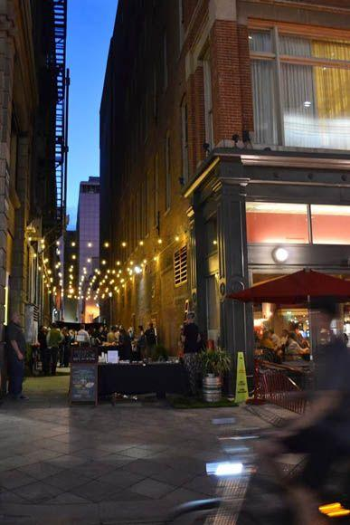

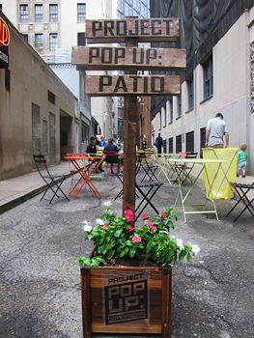

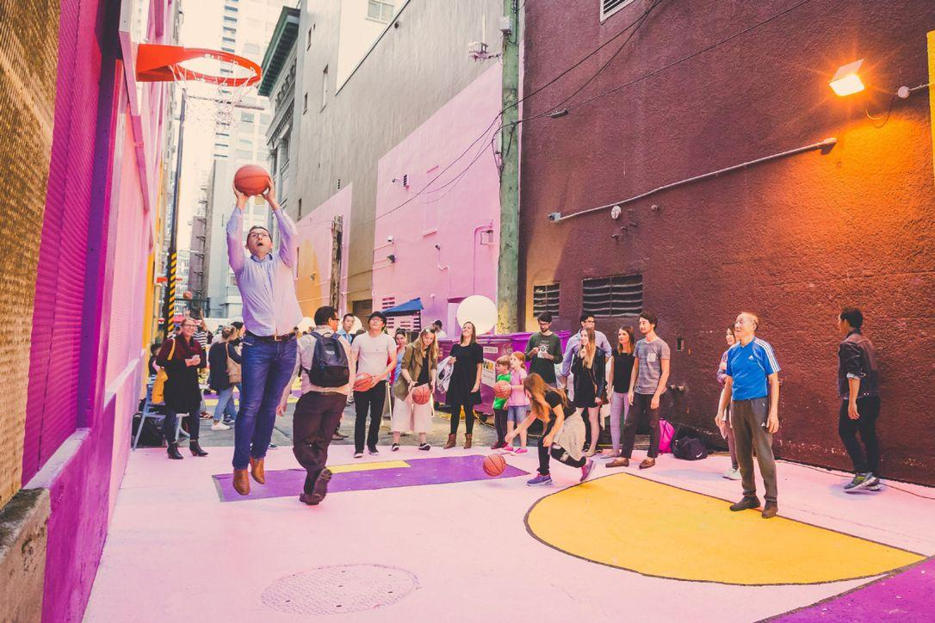

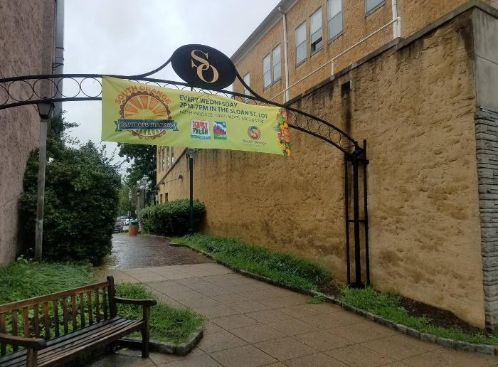
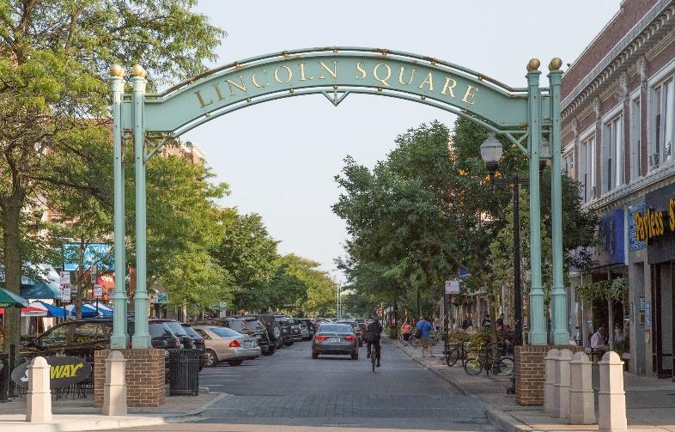
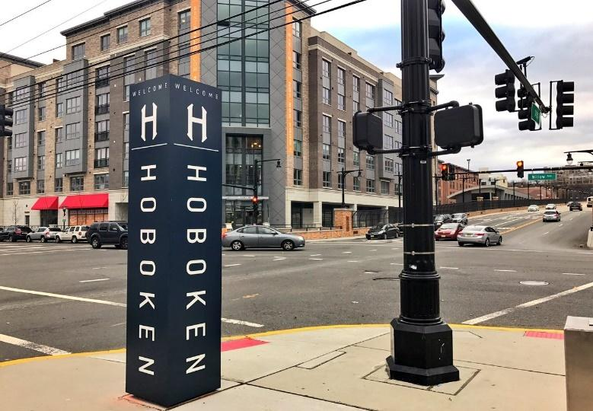
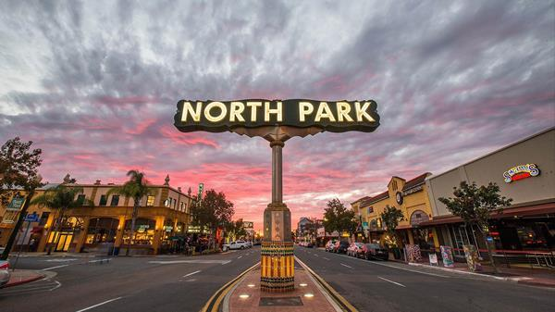
2. District Gateways – Branded Structures on, Adjacent to, or Across Streets or Alleys
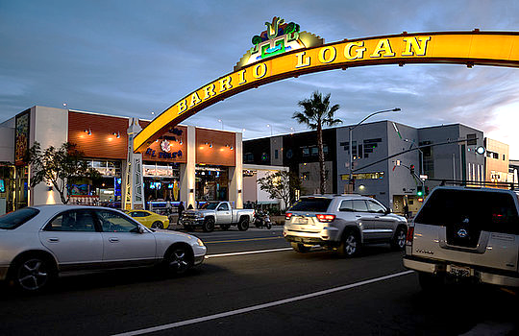
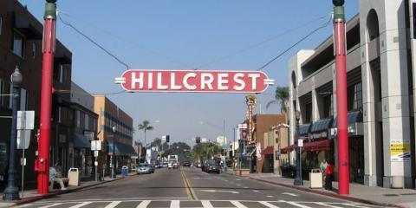

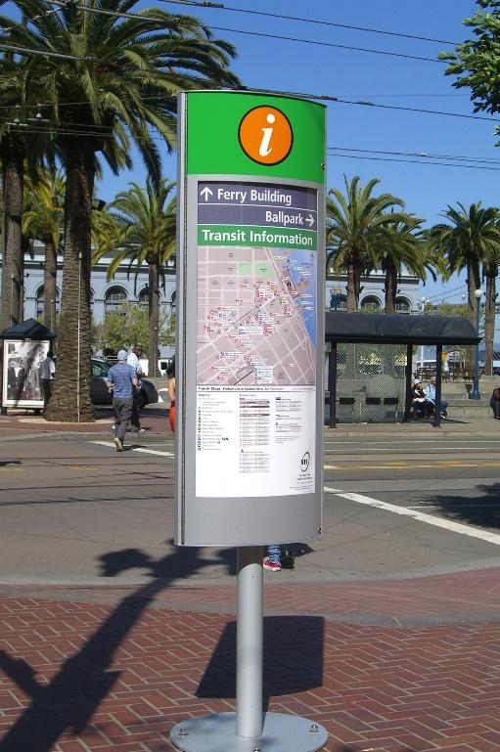
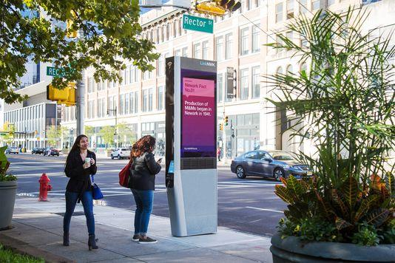
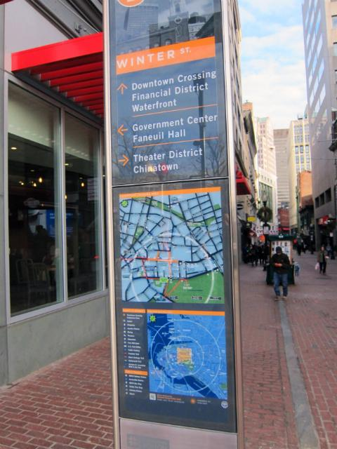
3. Information Kiosks - On Sidewalks, in Plazas, District Parks, or Alleys; Static or Digital
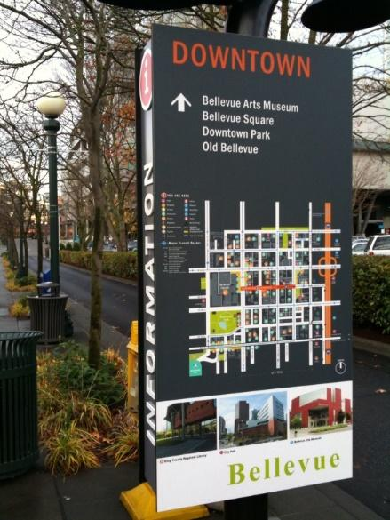
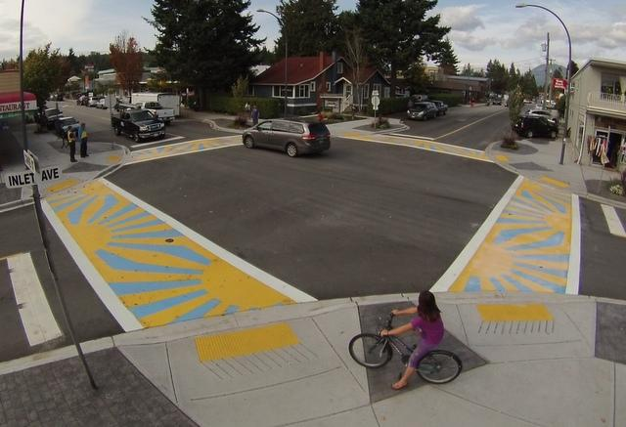
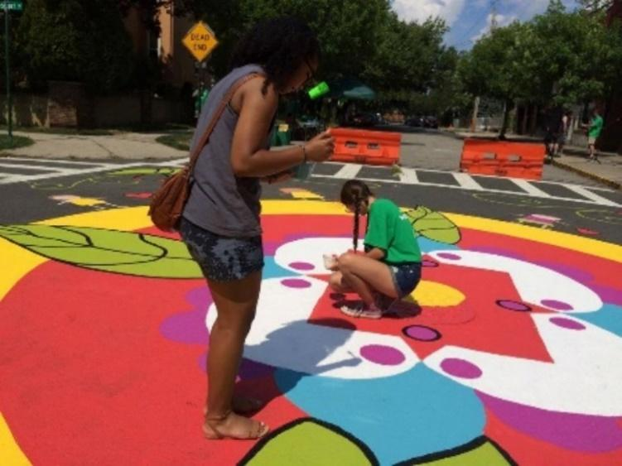
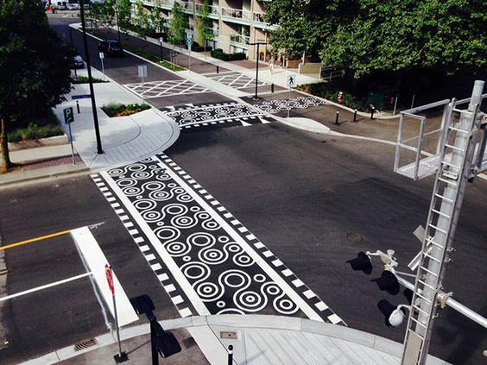
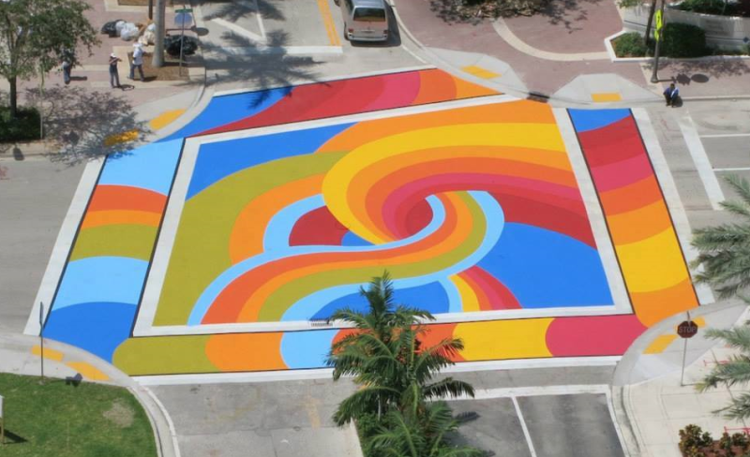
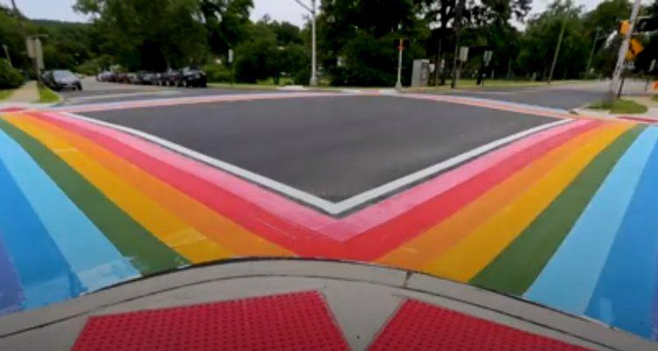
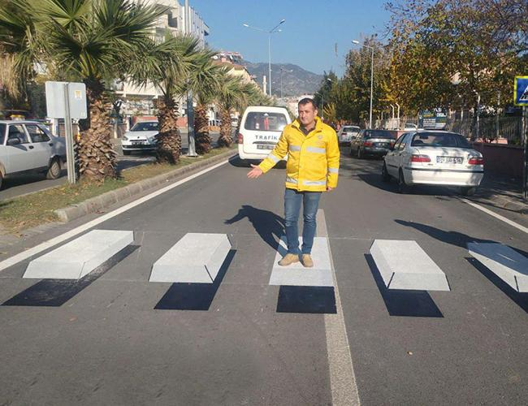
4. Enhanced Pedestrian Intersection or Street Crossings – Painted, Thermoplastic, or Hardscape Crosswalks; Full- or Partial-Intersection Treatments that May Include Lighting

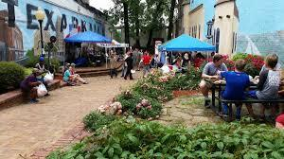
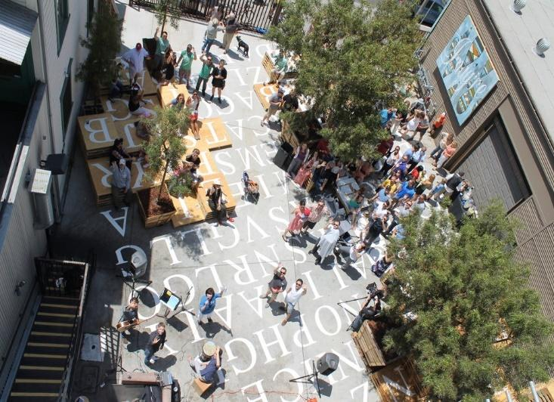
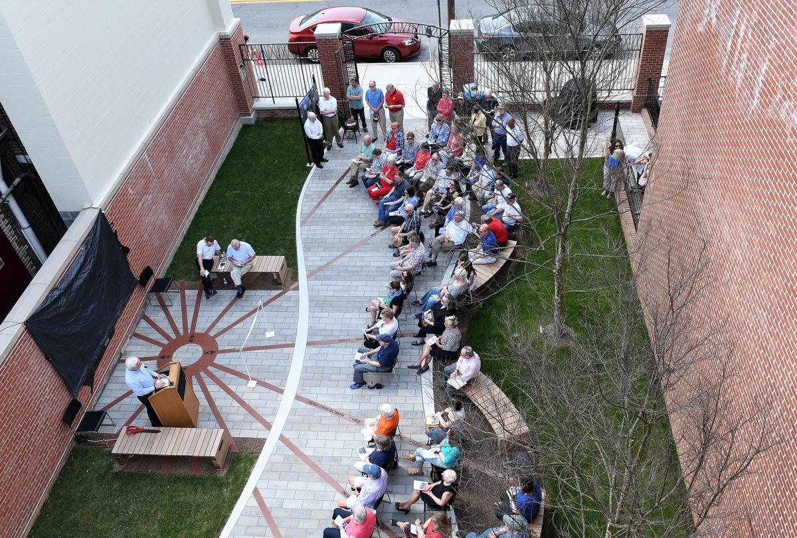
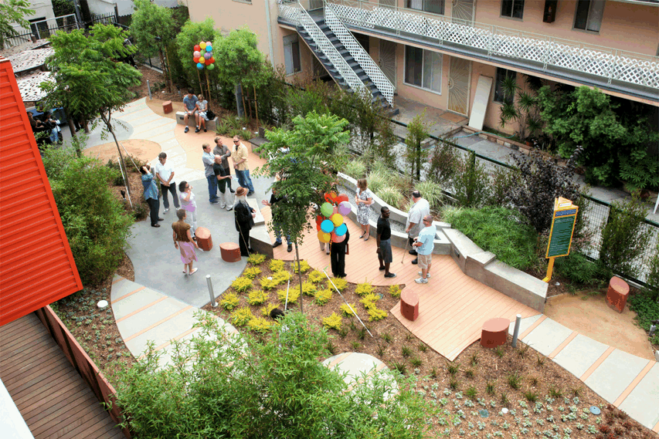
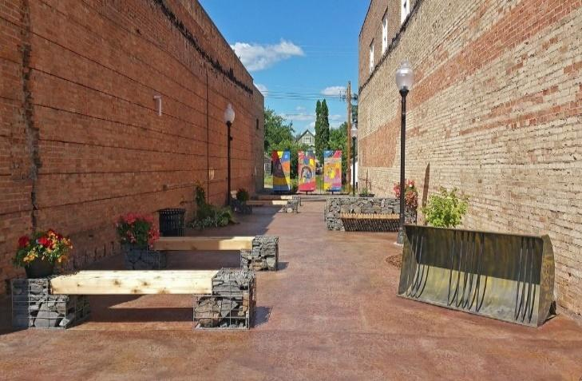
5. Pocket Parks – Natural Landscape, Public Activity Parks, Performance Parks; Hardscaping, Landscaping, Art, Lighting, Performance Space, Seating, Recreational Features
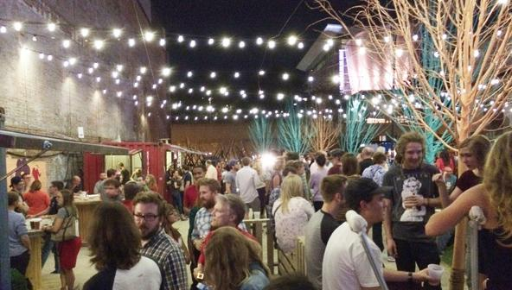

6. Parklets – Including Vertical and Horizontal Structures, Plantings, Art, Seating, Lighting, Recreational Features
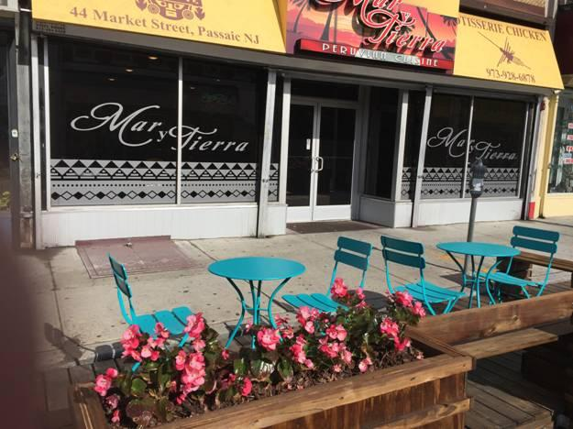
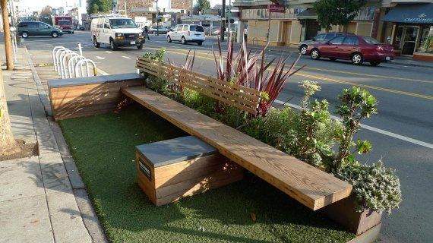
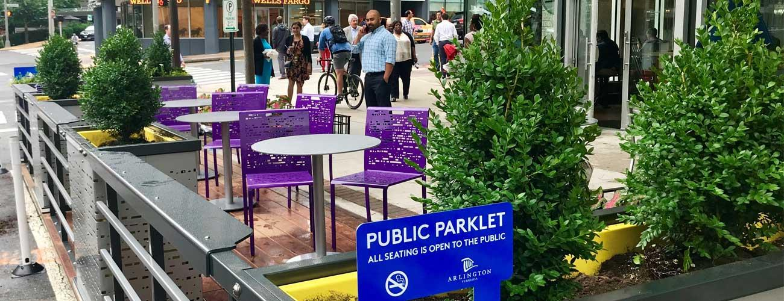
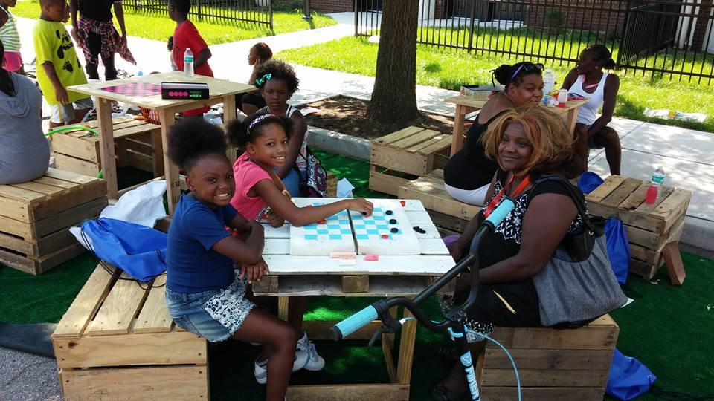
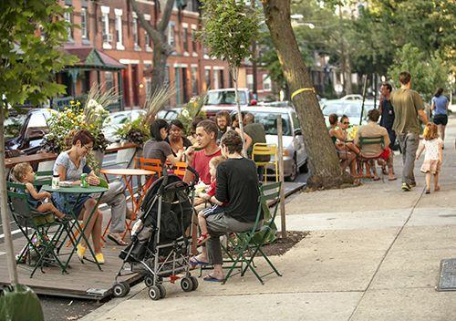
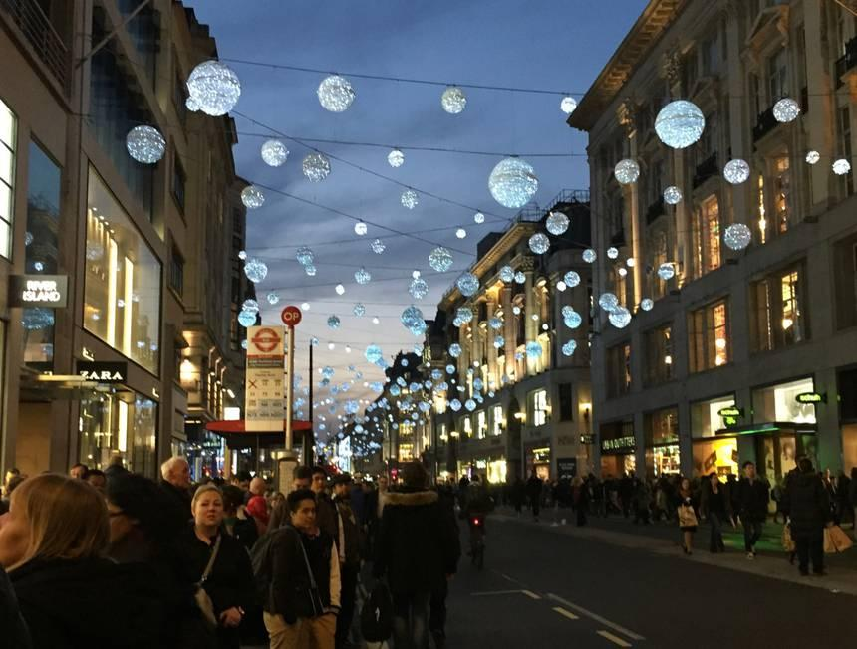
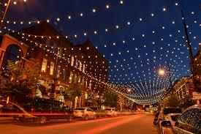
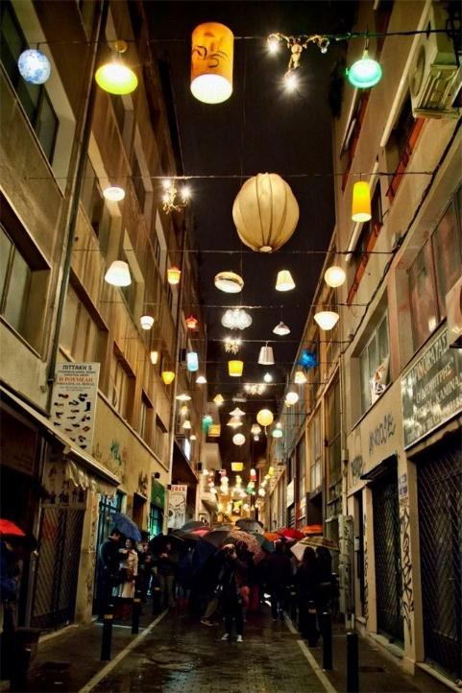
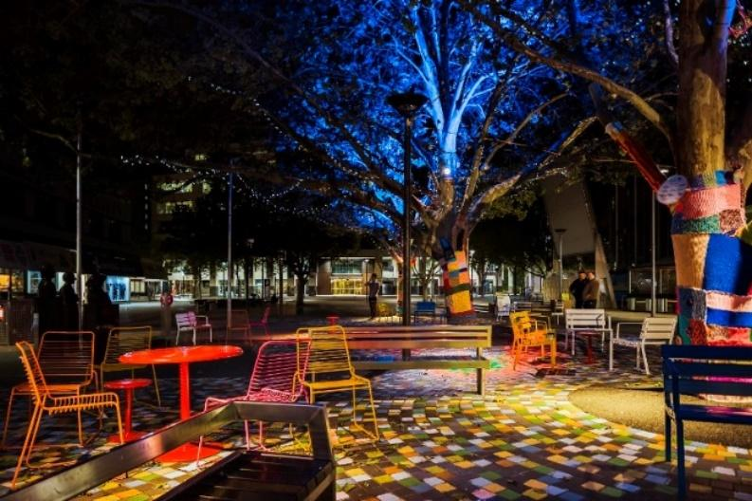
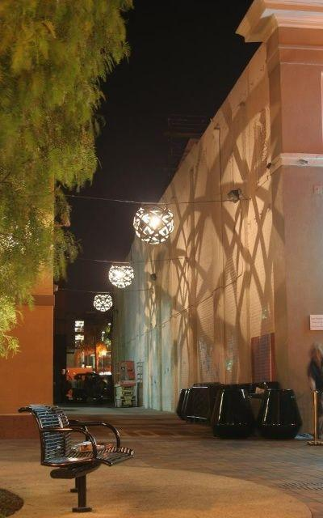
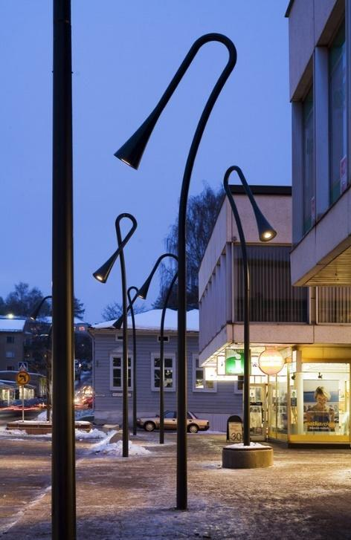
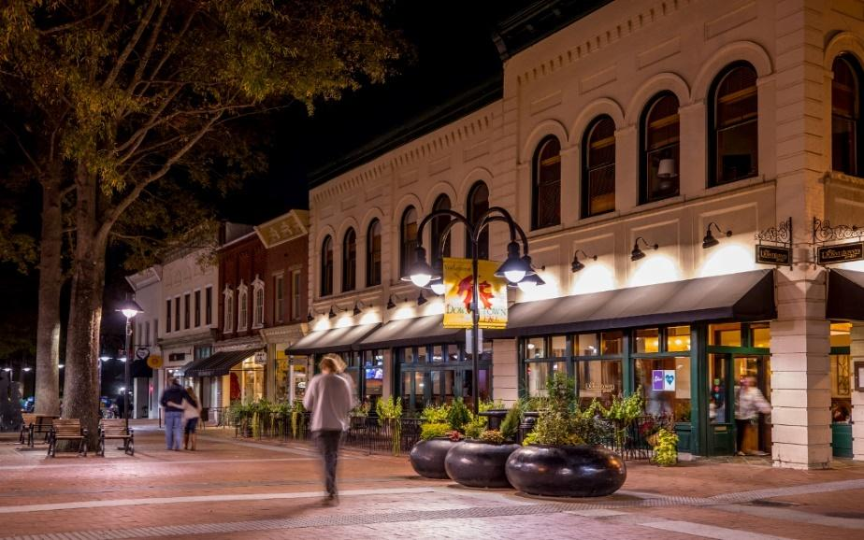
7. Pedestrian Realm Lighting – Across Plazas, Across Streets, Across or Along Sidewalks

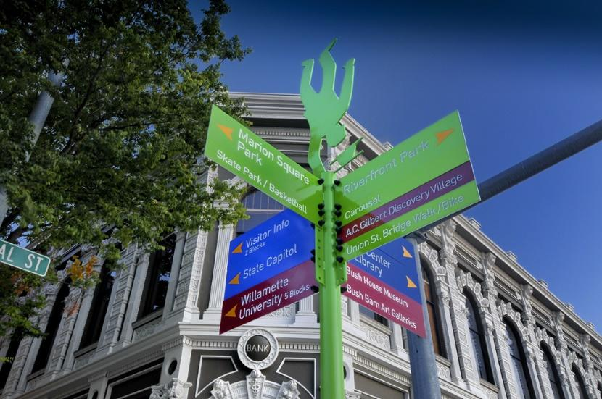
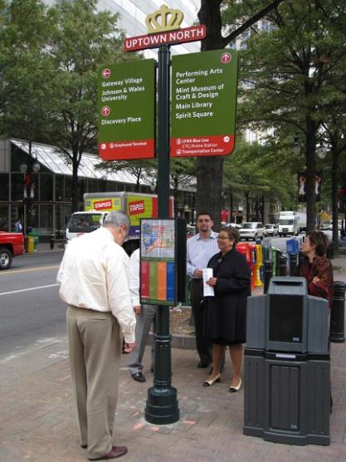
8. Pedestrian Scale Wayfinding – On Sidewalks, in Plazas or Alleys; for Businesses and Public Assets
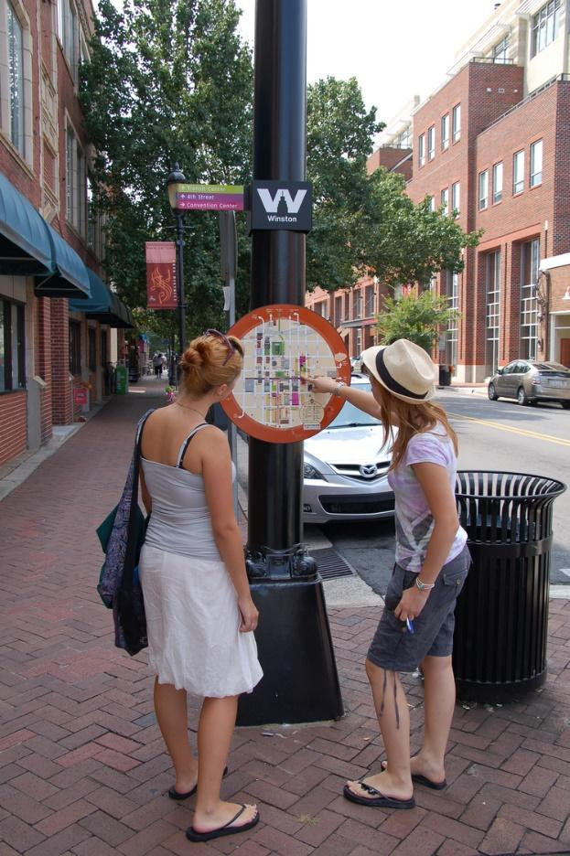

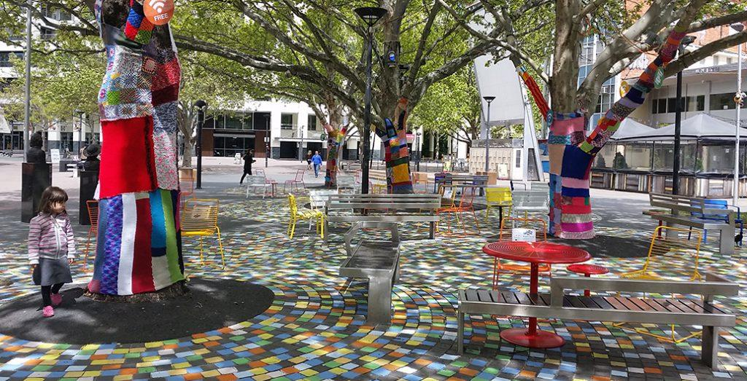
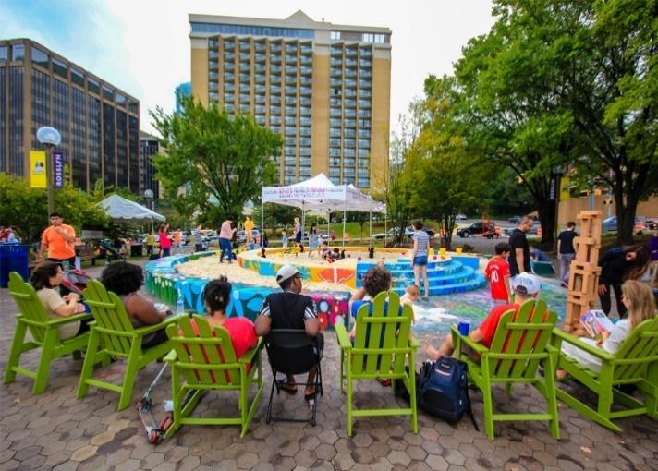
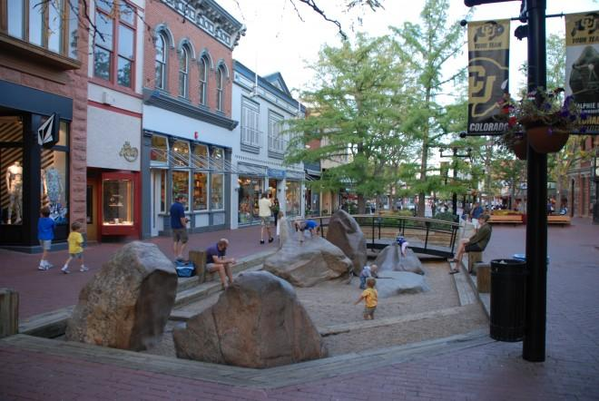
9. Plaza Creation or Enhancement – Paint, Hardscaping, Lighting, Outdoor Seating, Art, Performance Space, Recreational Features
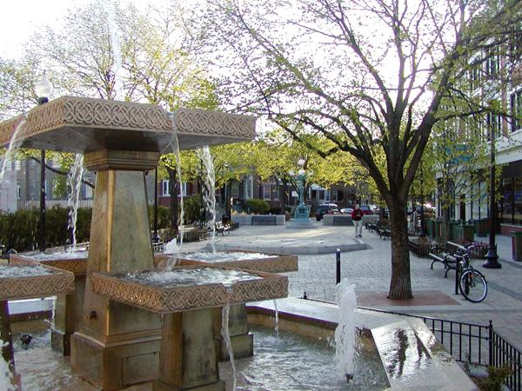

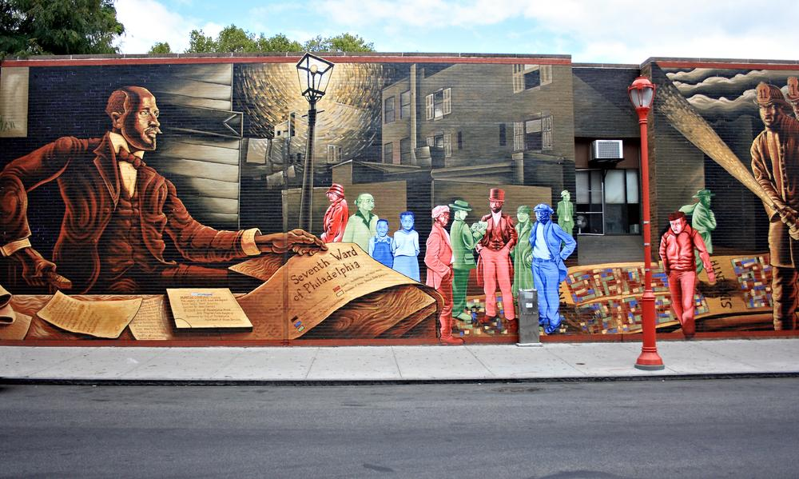
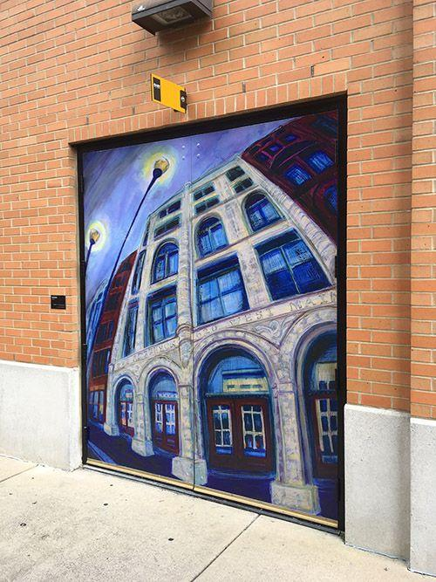
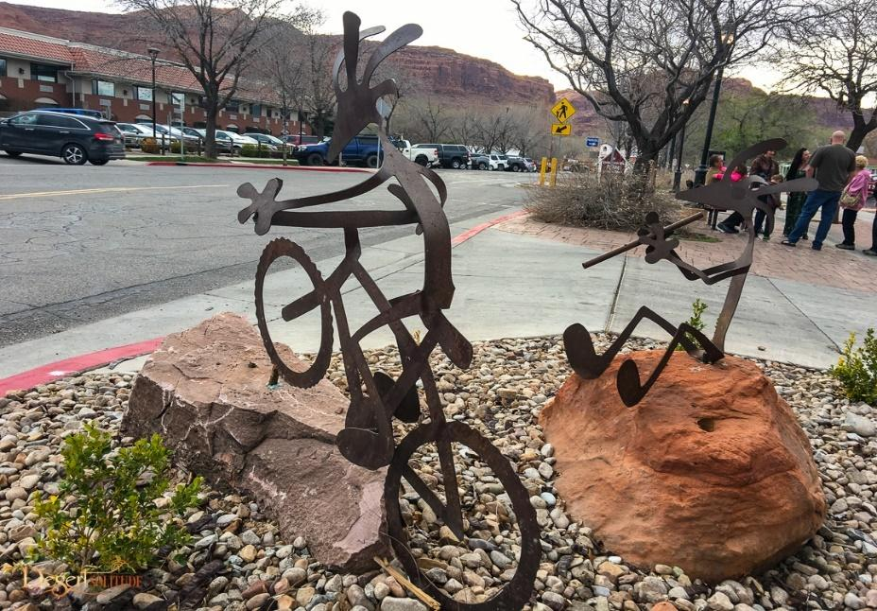
10. Public Art – Sculptures, Murals, Artistic Features, Stage Areas for Public Performances
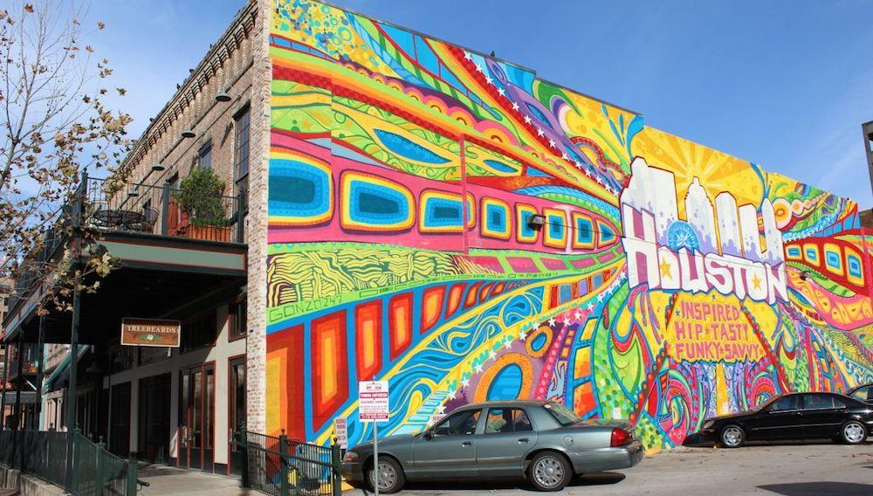
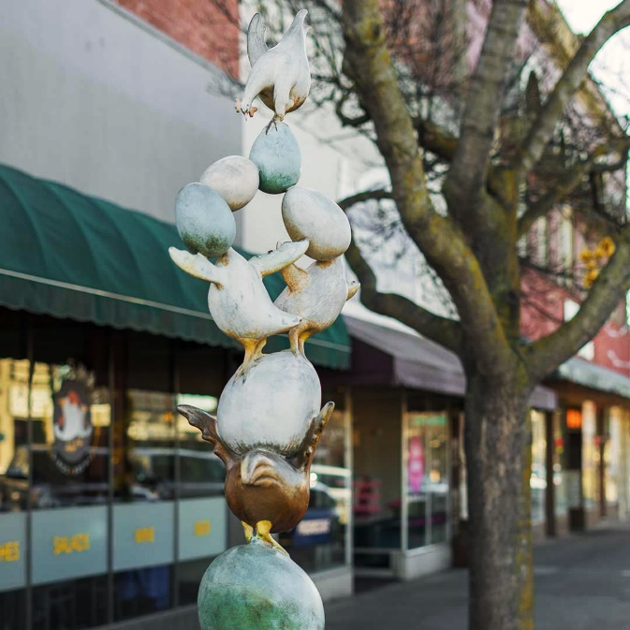
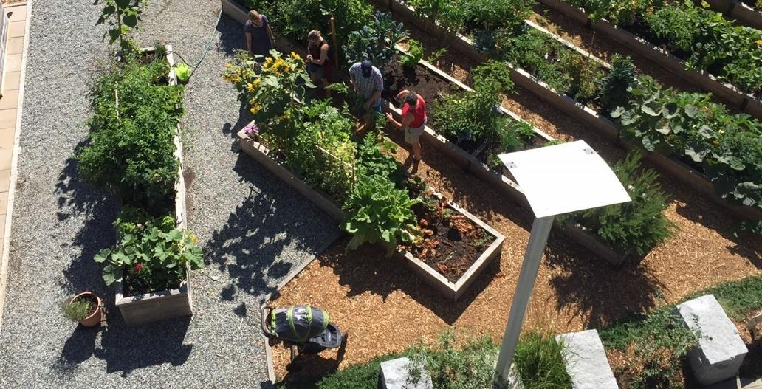
11. Public Gardens – Urban Food Gardens, Rain Gardens, Bioswales
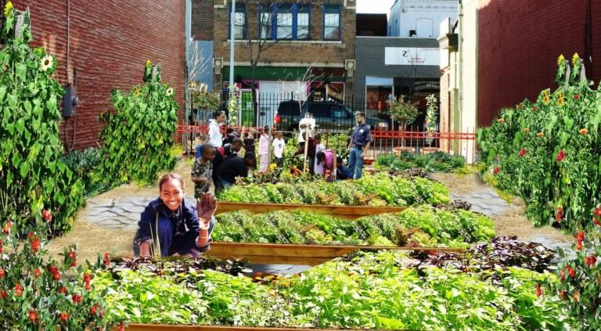
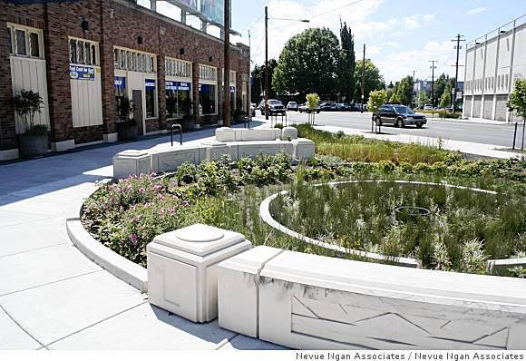
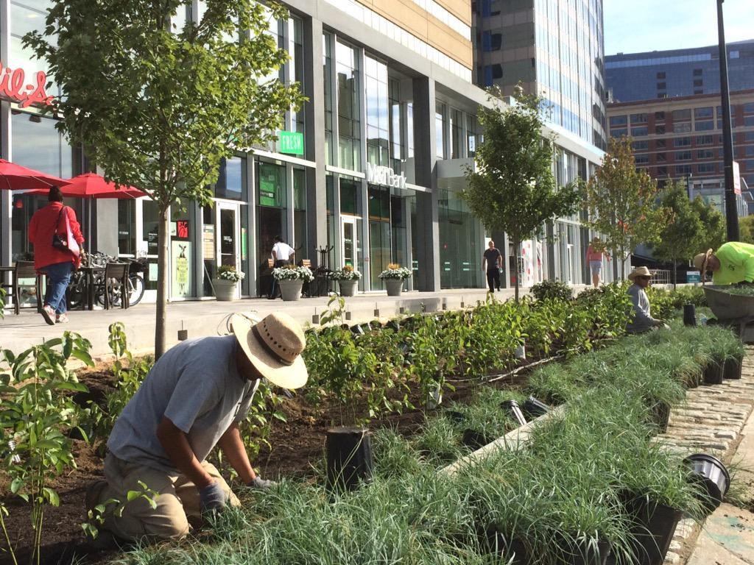
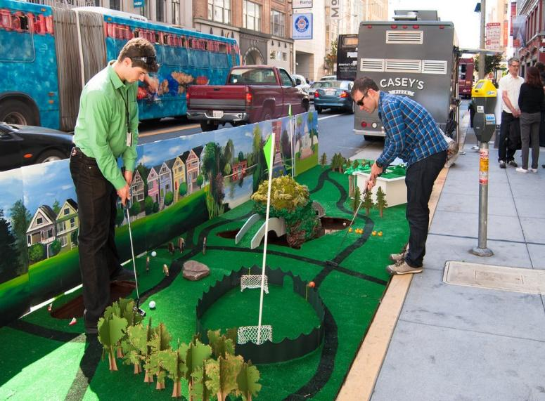
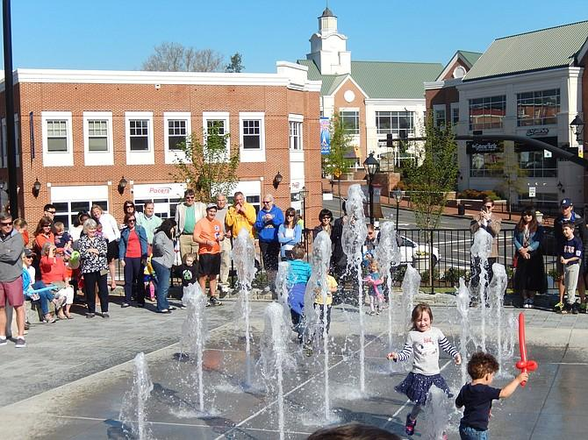
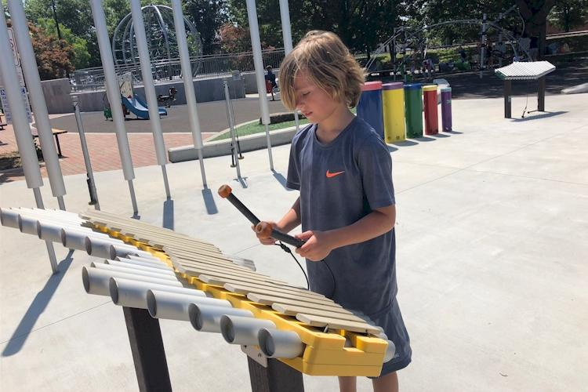
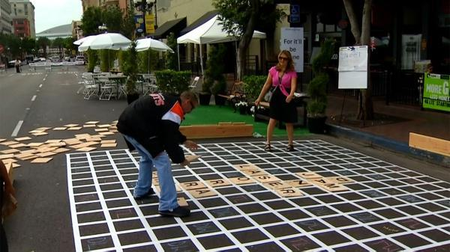
12. Public Recreational Features – Splash Pads, Musical Installations, Outdoor Games and Equipment
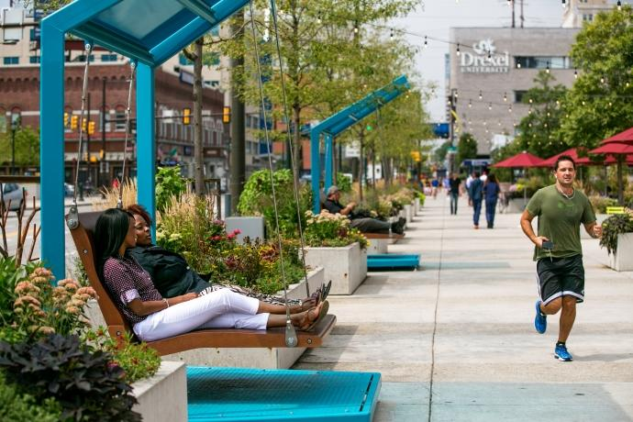

13. Public Outdoor Seating and Dining Areas – Moveable Seating and Tables for Public Use on Sidewalks and/or in Alleys and Plazas
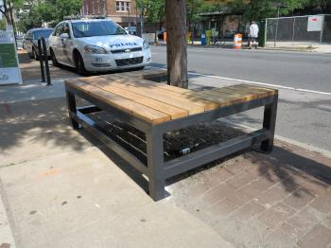
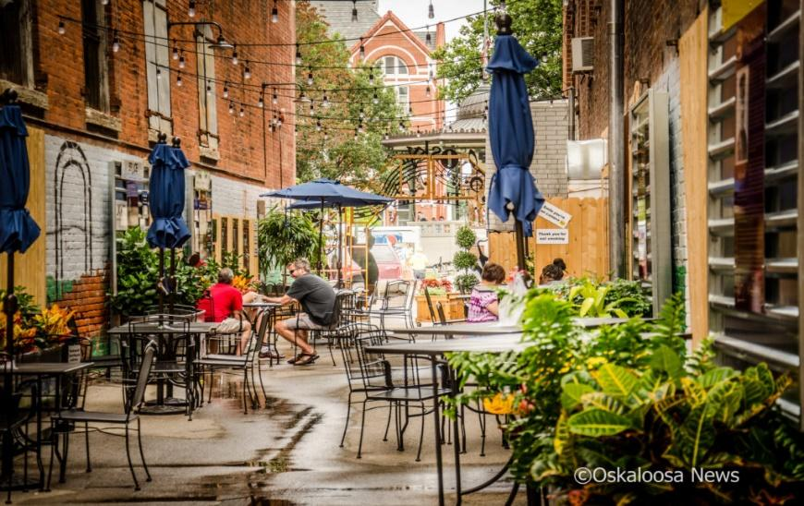
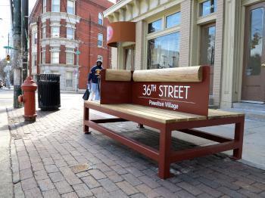
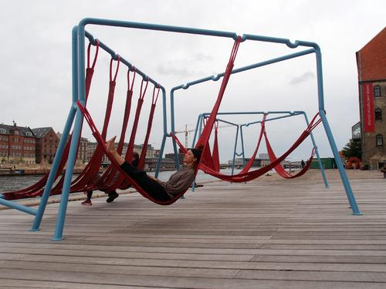
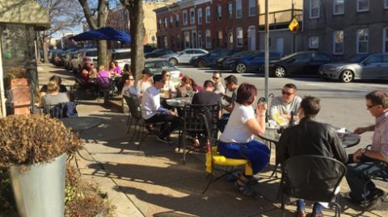
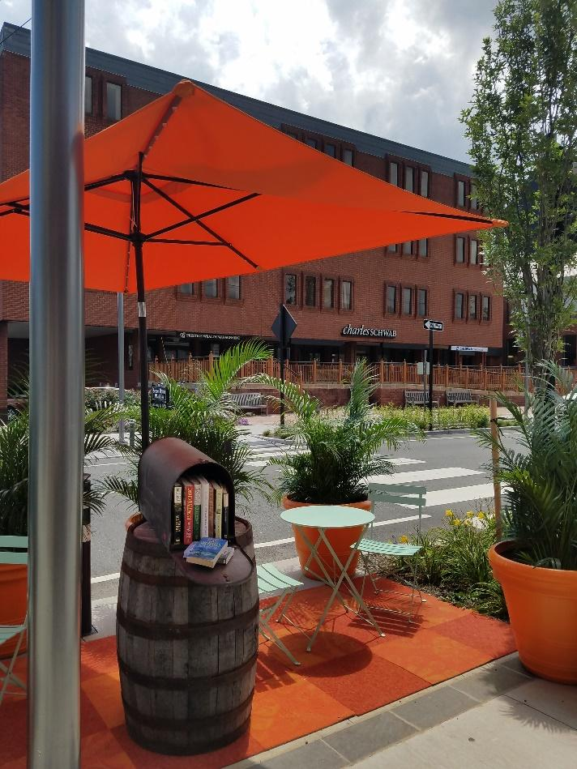
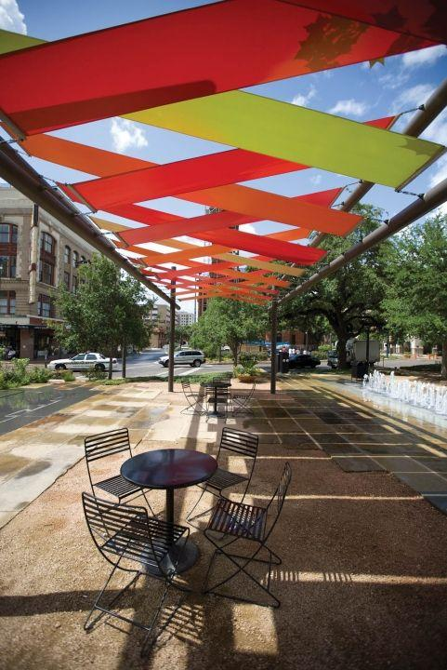
14. Shade Features – Mature Trees, Outdoor Umbrellas, Shade Sails, Pergolas (Living or Structural)
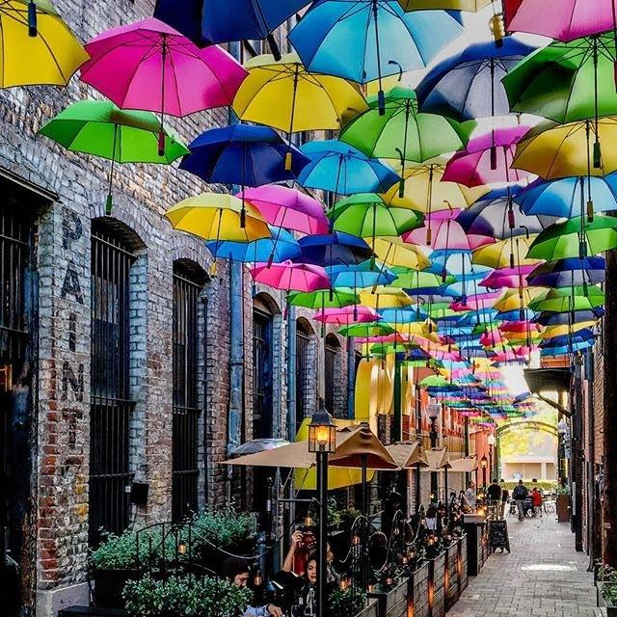
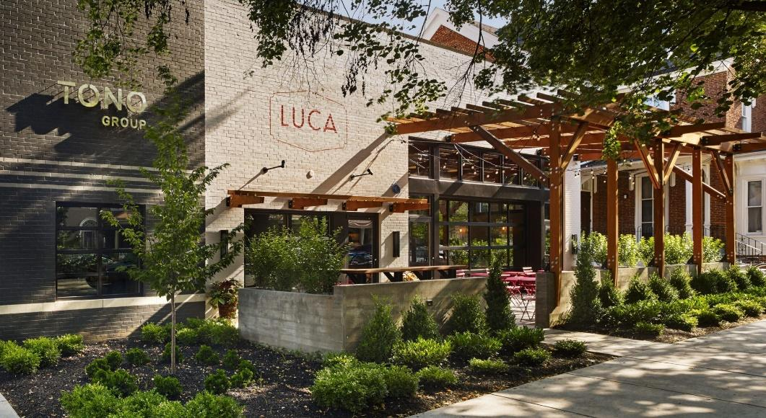

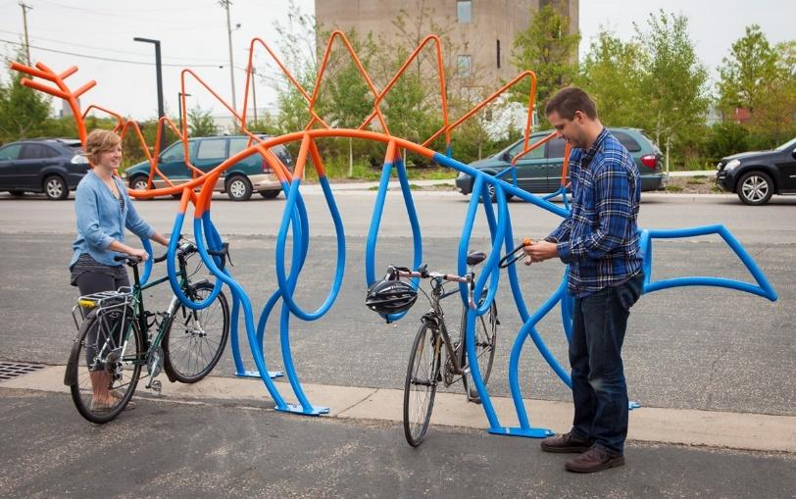
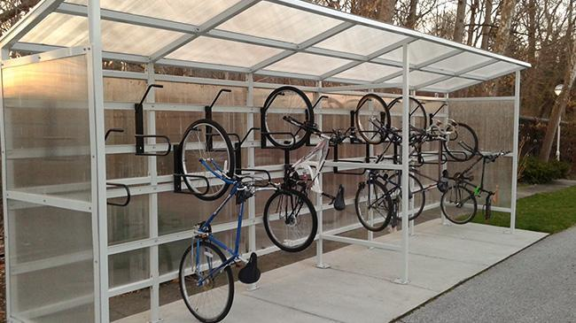
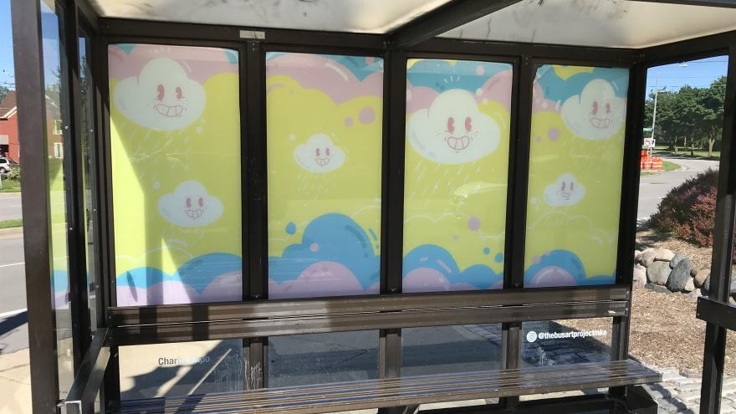
15. Transit and Non-Motorized Vehicle Shelters – Enhanced Bus/Rail Shelters, Bicycle Lockers/Storage/Stands; Lighting, Art
